

USB Gate Kicker Implementation  
Guide

Document Written: March 21st 2014

Consultant: Mathew Leroux

**Table of Contents**

Software and Hardware Requirements 3

Installation Instructions 4

Software and Hardware Requirements

Hardware:

The hardware used for testing was a VIE Technologies USB gate kicker. Any other USB gate kicker that emulates a serial port may also work, but have not been tested.

Software:

Browse to the following URL: <http://activenet.active.com/entrypoint>

From this site download the EntryPoint.exe and EntryPointUI.exe files.

Installation Instructions

Installing the Gate Kicker

1. Plug the gate kicker into the PC that will be used to kick the gates
2. From Windows open Control Panel > Device Manager
3. Under Ports (COM & LPT) check which port the gate kicker was assigned:  
   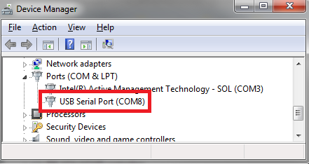

NOTE: It may be easier to tell which port was assigned by opening this screen before plugging in the gate kicker   
NOTE: Depending on the gate kicker used, drivers may need to be installed for this to show up

Preparing ActiveNet – Scanning User Creation

1. Log into ActiveNet
2. Open Administration Menu > System Settings > System Users
3. Create a new user similar to the following:  
   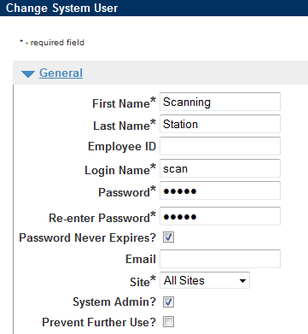
4. Save the user

Preparing ActiveNet – Entry Point

1. Log into ActiveNet
2. Open Administration Menu > Membership Settings > Entry Points
3. Select the Entry Point that the gate kicker is being added to
4. Configure the Scan/Gate Fields section similar to the following:  
   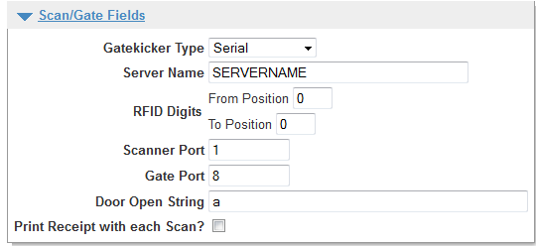
   1. Server Name – Any name will work, but the name will be used in a later step in the configuration
   2. Scanner Port – Enter the port number the scanner is configured for
   3. Gate Port – Enter the port number the gate kicker will use based on the Gate Kicker installation steps above
   4. Door Open String – ‘a’ will suffice for kicking the gate
5. Save Changes

Installing Java

Java is required for the EntryPoint software to run correctly. Install Java from [www.java.com](http://www.java.com) on the workstation that is going to use the gate kicker if it wasn’t previously installed. Take note of the path that Java installs to as it will be required for a later step.

Ex. C:\Program Files (x86)\Java

Installing EntryPoint.exe

The EntryPoint software communicates with the ActiveNet website. After downloading it from the ActiveNet website link from the previous section follow these installations steps:

1. Run the EntryPoint.exe file
2. At the configuration screen during the install setup fill in the fields similar to this screenshot:  
   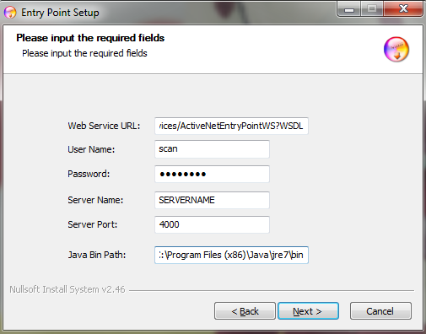
   1. WebService URL should be filled in following the steps below:
      1. Log into the ActiveNet website
      2. Looking at the Url and copy the portion highlighted in red below ending at /servlet/  
         
      3. Change HTTPS:// to HTTP://
      4. Add /services/ActiveNetEntryPointWS?WSDL to the end of the URL
      5. The resulting URL should be similar to this:  
         <http://activenet020.active.com/burnaby64/servlet/services/ActiveNetEntryPointWS?WSDL>
   2. User Name and Password should be filled in with the user account information created in a previous step
   3. Server Name should be filled in to match the server name given at the Entry Point level from a previous step
   4. Server Port can be left at the default of 4000   
      NOTE: Make sure this port isn’t blocked on the network
   5. Java bin path must be filled in using the path Java was installed in a previous step down to the /bin/ folder similar to this:  
      C:\Program Files (x86)\Java\jre7\bin
3. Complete the installation
4. Copy the Jacob.dll file to the Java bin folder
   1. Browse to the Entry Point installation folder:  
      C:\ActiveNetClient\Entrypoint
   2. Copy the file Jacob.dll
   3. Browse to the Java bin folder:  
      C:\Program Files (x86)\Java\jre7\bin
   4. Paste the Jacob.dll file into the folder
5. Confirm the Windows Service is running:  
   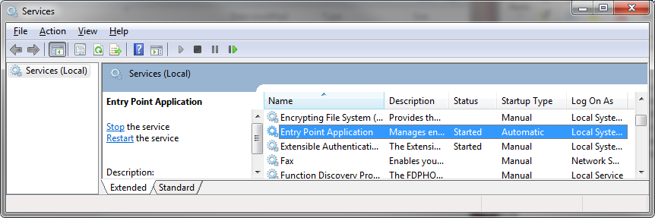

Installing EntryPointUI.exe

The Entry Point UI is used to view scanning information happening at the scanning station. It does not appear in the ActiveNet interface. After downloading it from the ActiveNet website link from the previous section follow these installations steps:

1. Run the EntryPointUI.exe file
2. Configure the installation options similar to this screenshot:  
   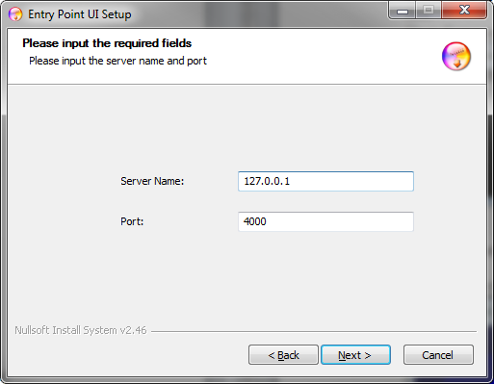
   1. Fill in the Server Name with the IP of the machine that the EntryPoint.exe file was installed to (if it’s the same machine, 127.0.0.1 will work)
   2. Fill in the Port with the Port configured during the EntryPoint.exe install

Testing the Gate Kicker

1. Open the Entry Point Monitor from the Start Menu > All Programs > Entry Point UI > Entry Point UI
2. Use the dropdown Select Entry Point to choose the Entry Point using the gate kicker
3. Press Open to kick the gate

